SAULT COLLEGE OF APPLIED ARTS AND TECHNOLOGY

SAULT STE. MARIE, ONTARIO

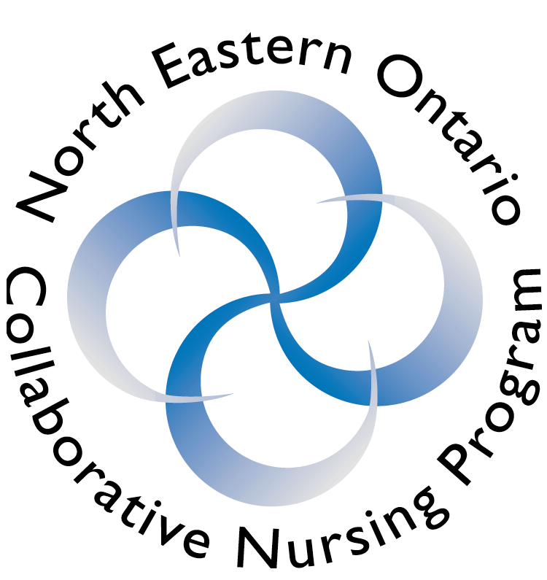

COURSE OUTLINE

COURSE TITLE: | Health III: Primary Health Care and Health Promotion
CODE NO. : | NURS 3005 |  | SEMESTER: | 5 & 6
PROGRAM: | BScN
AUTHOR: | Kay Vallee, Sault College
DATE: | Aug. 2011 | PREVIOUS OUTLINE DATED: |  |  | August, 2010
APPROVED: | “Marilyn King” |  |  |  | Aug. 2011
 | __________________________________  CHAIR, HEALTH PROGRAMS |  |  |  | ___________  DATE
TOTAL CREDITS: | 6
PREREQUISITE(S):  CO-REQUISITE: | NURS 2144  NURS 3084, NURS 3094
HOURS/WEEK: | 3 hours classroom

Copyright ©2011 The Sault College of Applied Arts & Technology
Reproduction of this document by any means, in whole or in part, without prior

written permission of Sault College of Applied Arts & Technology is prohibited.

For additional information, please contact the Chair, Health Programs
School of Health and Community Services
(705) 759-2554, Ext. 2689

I. | COURSE DESCRIPTION:  The course is grounded in a primary health care framework. Basic concepts, principles and theoretical frameworks informing community health nursing in the context of prevention, health protection and health promotion are explored. Health will be examined from the population health promotion perspective. Through class discussion, small group activities and course assignments students will develop their understanding of community as client and partner and develop their repertoire of strategies for prevention, health promotion and health protection in the community setting.
II. | LEARNING OUTCOMES AND ELEMENTS OF THE PERFORMANCE:  Ends In View:  The learner will be able to:  - describe basic principles, concepts, theoretical frameworks informing community health nursing  - delineate the diversity of roles and functions of community health nurses  - interpret key epidemiological concepts and common epidemiological measurements  - conduct a community health assessment on an assigned community to identify community health needs for an aggregate and plan appropriate health promotion activities to address priority community health needs for assigned community  - describe the health program planning process and its application to nursing in the community  - summarize models, theories and frameworks of health promotion and community change  - demonstrate knowledge of strategies for prevention, health protection and health promotion when working with individuals, families, groups, aggregates and communities  - demonstrate knowledge of environmental health, international health and global health issues as they apply to community health nursing  - prepare a health promotion grant application to address a health need of an aggregate based on the conducted community health assessment  - demonstrate knowledge and strategies required to work as a team member

Process:
Active co-operative learning is the philosophical approach in this course. Participants will develop a sense of community health nursing practice and develop social and political awareness in a variety of community contexts by engaging in a variety of learning experiences such as: discussion, debate, case study analysis, health communication development, class presentation, community health assessment, health promotion grant proposal preparation, and critical reflection.

III. | TOPICS:
The course content is organized around learning activities that reflect the following topics:

- Key concepts of community health nursing
- Historical evolution of community health nursing in Canada
- Canadian Community Health Nursing Standards of Practice
- Primary health care
- Determinants of health
- Settings, roles and functions of community health nurses
- Ethics in community health nursing practice
- Epidemiological applications
- Community health nursing process
- Program planning, monitoring and evaluation
- Models and frameworks of health promotion and theories of community change
- Social marketing, advocacy and community development
- Tools for community health nursing practice
- Sustaining healthy communities
- Environmental health
- International/global health
- Team/group process

IV. | REQUIRED RESOURCES/TEXTS/MATERIALS:  Stanhope, M., Lancaster, J., Jessup-Falcioni, H., & Viverais-Dresler, G. (2011). Community health nursing in Canada (2nd ed.). Toronto, ON: Elsevier.  Vollman, A., Anderson, E., & McFarlane, J. (2012). Canadian community as  partner: Theory and multidisciplinary practice (3rd ed.). Philadelphia, PA: Lippincott.
Additional Reference Resources

Community Health Nurses of Canada. (2011). Canadian community health nursing professional practice model and standards of practice. Community Health Nurses of Canada. Available from http://www.chnc.ca/documents/CHNC-ProfessionalPracticeModel-EN/index.html

Diem, E. & Moyer, A. (2005). Community health nursing projects: Making a difference. Philadelphia: Lippincott Williams & Wilkins.

Hales, D. & Lauzon, L. (2010). An invitation to health (2nd Can. ed.). Toronto, ON: Nelson.

V. | EVALUATION PROCESS/GRADING SYSTEM:  Assignments have been selected to complement the course content and prepare the learner for the community clinical practice component in NURS3084 and NURS3094.  Credit for this course requires successful completion and submission of all of the following:  - Community Health Assessment - Team Project I 15%  - Mid-Term Class Test 30%  - Health Promotion Grant Application - Team Project II 15%  - Health Promotion Grant Poster Presentation and Self  Reflection - Team Project III 5%  - Final Exam 35%  Note: Refer to syllabus for further description and requirements for assignments. All students may not receive the same mark for a team assignment, as in some cases there is an individual component added to the team submission. Team members who do not contribute according to team expectations may have marks deducted from their grade for the relevant assignment. Teams are required to record meeting dates, time, and group process.  Each team will also be required to facilitate one NURS3005 class during the year. There is no grade assigned to this activity as it is an expectation of participative learning. Refer to syllabus for more detail.

 | The following semester grades will be assigned to students:
 | Grade | Definition | Grade Point Equivalent
 | A+ | 90 – 100% | 4.00
 | A | 80 – 89%
 | B | 70 - 79% | 3.00
 | C | 60 - 69% | 2.00
 | D | 50 – 59% | 1.00
 | F (Fail) | 49% and below | 0.00
 | CR (Credit) | Credit for diploma requirements has been awarded.
 | S | Satisfactory achievement in field /clinical placement or non-graded subject area.
 | U | Unsatisfactory achievement in field/clinical placement or non-graded subject area.
 | X | A temporary grade limited to situations with extenuating circumstances giving a student additional time to complete the requirements for a course.
 | NR | Grade not reported to Registrar's office.
 | W | Student has withdrawn from the course without academic penalty.

NOTE: Mid Term grades are provided in theory classes and clinical/field placement experiences. Students are notified that the midterm grade is an interim grade and is subject to change.

VI. | SPECIAL NOTES:  BScN Student Manual  Students in the nursing program are responsible for adhering to the information, policies and procedures in the 2010/2011 Sault College BScN Student Manual.  Attendance:  Sault College is committed to student success. There is a direct correlation between academic performance and class attendance; therefore, for the benefit of all its constituents, all students are encouraged to attend all of their scheduled learning and evaluation sessions. This implies arriving on time and remaining for the duration of the scheduled session.
VII. | COURSE OUTLINE ADDENDUM:
 | The provisions contained in the addendum are located on the portal and form part of this course outline.

